ANSIBLE -02
- Watch ansible-02 video and write down notes.
Ansible is an open-source automation platform used for configuration management, application deployment, and task orchestration across multiple servers. It follows an agentless architecture, meaning no software is required on managed nodes and communication is performed using SSH. Ansible automation is defined using playbooks written in YAML format. A playbook consists of one or more plays, and each play contains a set of tasks. These tasks execute built-in modules such as apt, service, copy, and file to perform actions on target systems. An inventory file is used to list and organize the managed hosts. Ansible also supports handlers, which are special tasks that run only when notified, usually to restart or reload services. The notify directive is used within tasks to trigger these handlers when changes occur. Overall, Ansible offers a simple, readable, and reliable approach to automating IT operations.
- Install httpd using ansible playbook, use handlers,notifiers.
Create the directory
Mkdie playbook
Cd playbook
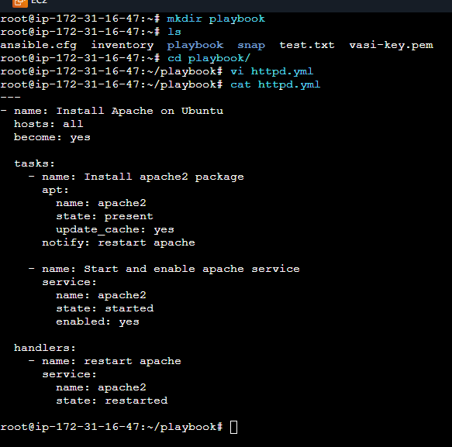

- ansible-playbook httpd.yml --syntax-check
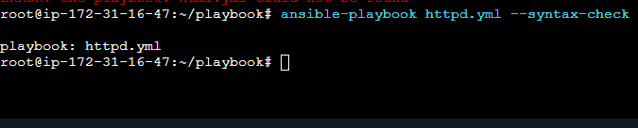
- ansible-playbook httpd.yml --check
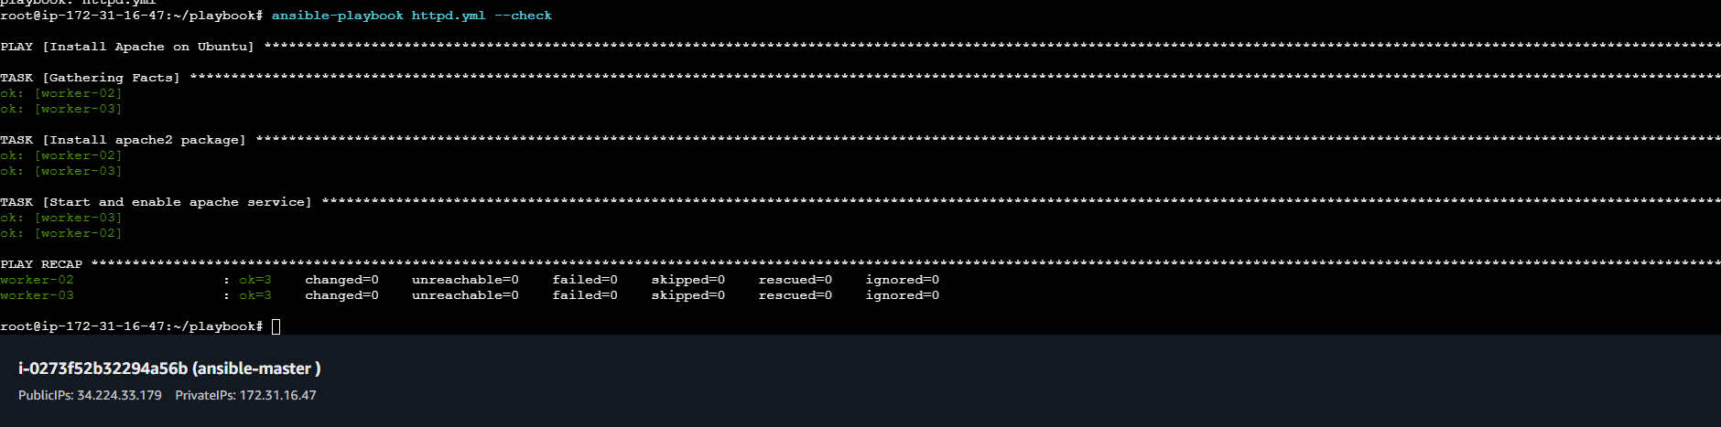
- check the server is active are not
- Systemctl status apache2
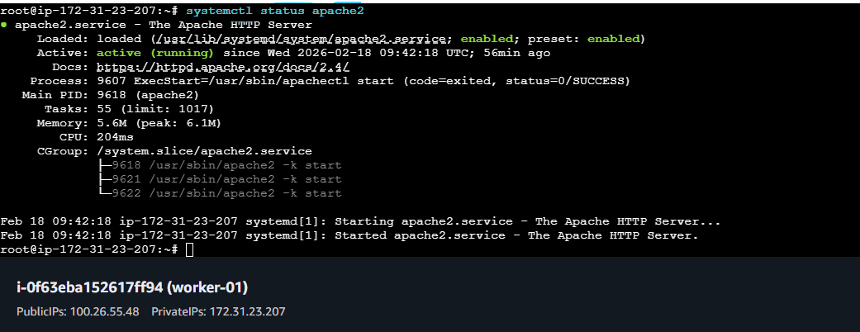

- Worker -01
- ubuntu is working
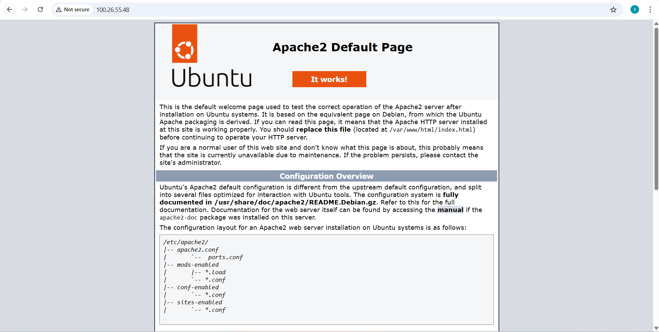
- check the server is active are not
- Systemctl status apache2
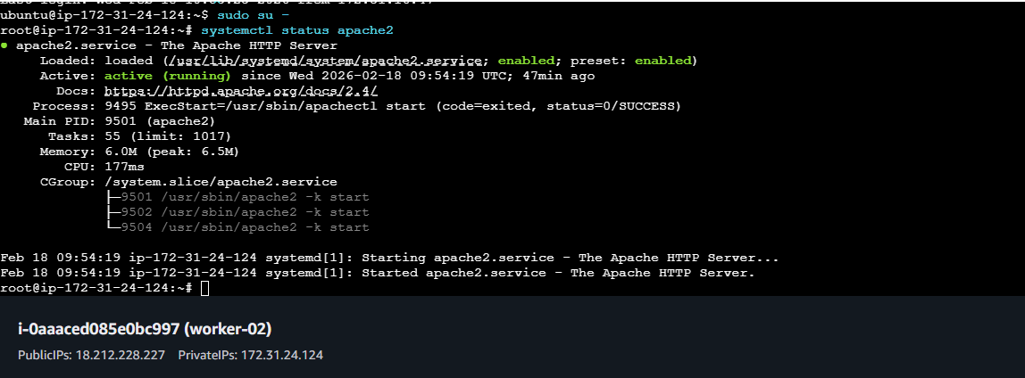

- Worker -02 ubuntu is working
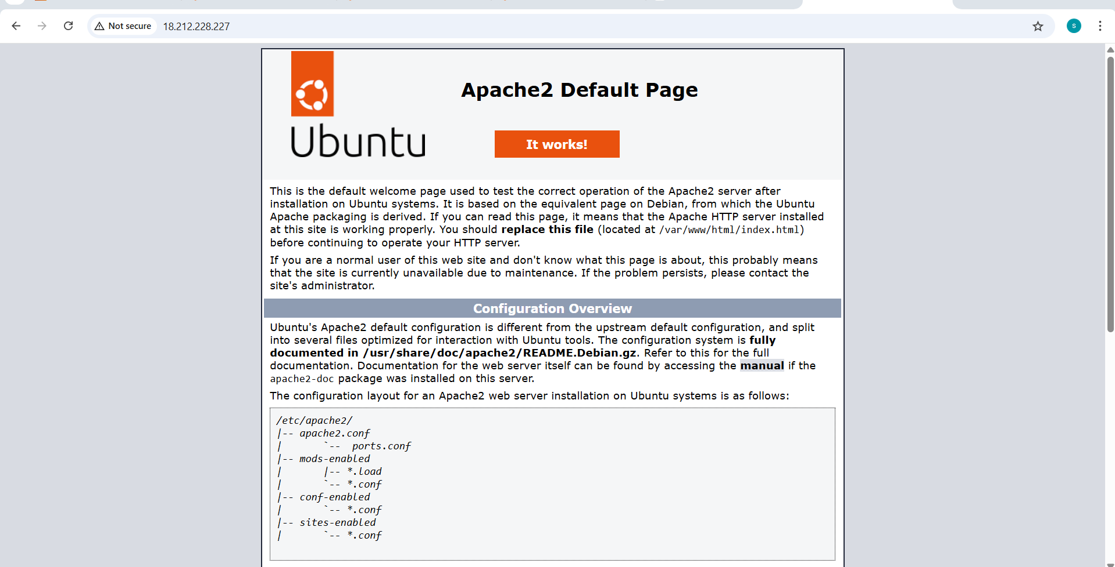
3.Write a ansible playbook to install apache tomcat.
---
- name: Install and configure Apache Tomcat
hosts: workers
become: yes

vars:
tomcat_version: 9.0.96
tomcat_user: tomcat
tomcat_group: tomcat
tomcat_home: /opt/tomcat

tasks:
- name: Install Java
apt:
name: default-jdk
state: present
update_cache: yes

- name: Create tomcat group
group:
name: "{{ tomcat_group }}"

- name: Create tomcat user
user:
name: "{{ tomcat_user }}"
group: "{{ tomcat_group }}"
shell: /bin/false
home: "{{ tomcat_home }}"

- name: Download Tomcat
get_url:
url: "https://archive.apache.org/dist/tomcat/tomcat-9/v{{ tomcat_version }}/bin/apache-tomcat-{{ tomcat_version }}.tar.gz"
dest: /tmp/tomcat.tar.gz

- name: Create Tomcat directory
file:
path: "{{ tomcat_home }}"
state: directory

- name: Extract Tomcat
unarchive:
src: /tmp/tomcat.tar.gz
dest: "{{ tomcat_home }}"
remote_src: yes
extra_opts: [--strip-components=1]

- name: Set permissions
file:
path: "{{ tomcat_home }}"
owner: "{{ tomcat_user }}"
group: "{{ tomcat_group }}"
recurse: yes

- name: Create Tomcat systemd service
copy:
dest: /etc/systemd/system/tomcat.service
content: |
[Unit]
Description=Apache Tomcat
After=network.target

[Service]
Type=forking
User=tomcat
Group=tomcat
Environment="JAVA_HOME=/usr/lib/jvm/default-java"
Environment="CATALINA_HOME=/opt/tomcat"
Environment="CATALINA_BASE=/opt/tomcat"
ExecStart=/opt/tomcat/bin/startup.sh
ExecStop=/opt/tomcat/bin/shutdown.sh
Restart=always

[Install]
WantedBy=multi-user.target
notify: restart tomcat

- name: Reload systemd
systemd:
daemon_reload: yes

- name: Enable and start Tomcat
systemd:
name: tomcat
enabled: yes
state: started
handlers:
- name: restart tomcat
systemd:
name: tomcat
state: restarted
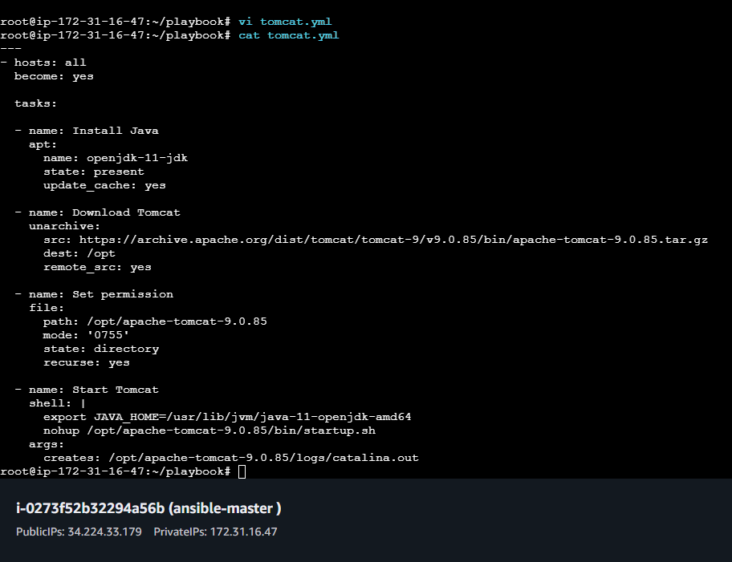
- Syntax-check
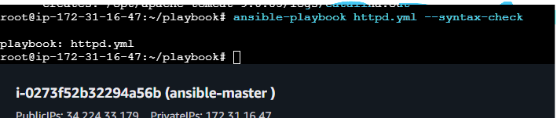
- Checking the tomcat
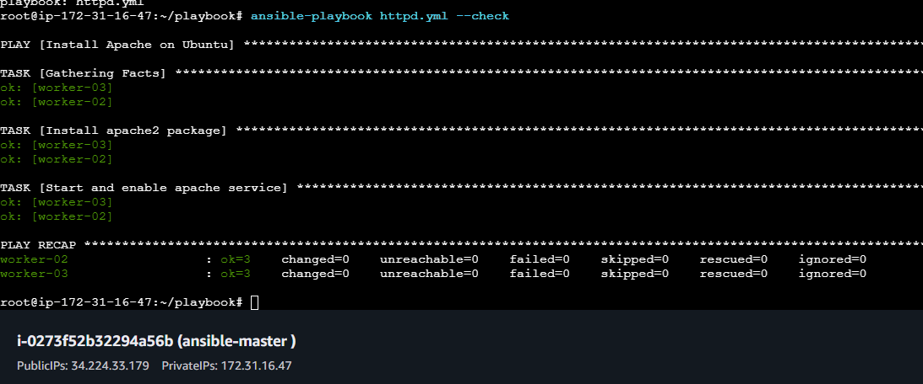
Check the server is running or not
Systemctl status tomcat
Worker-01

ls /opt/
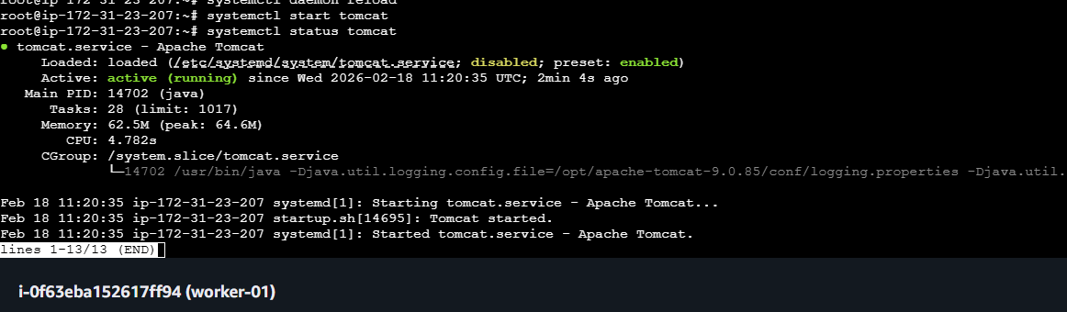

http://100.26.55.48:8080/
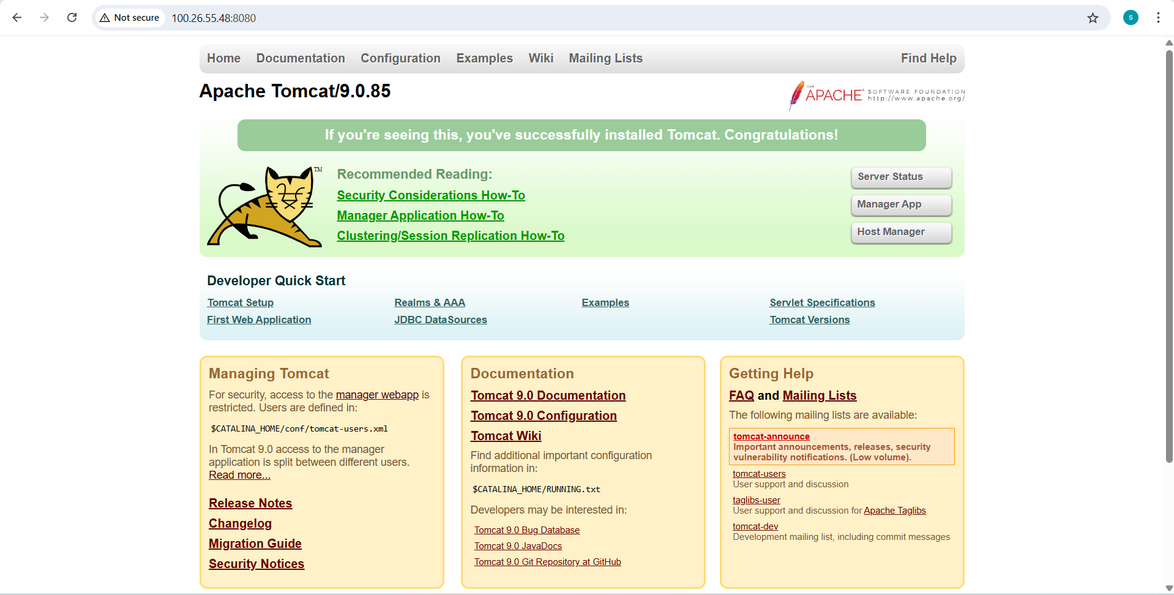
Check the server is running or not
Systemctl status tomcat
Worker-02
ls /opt/
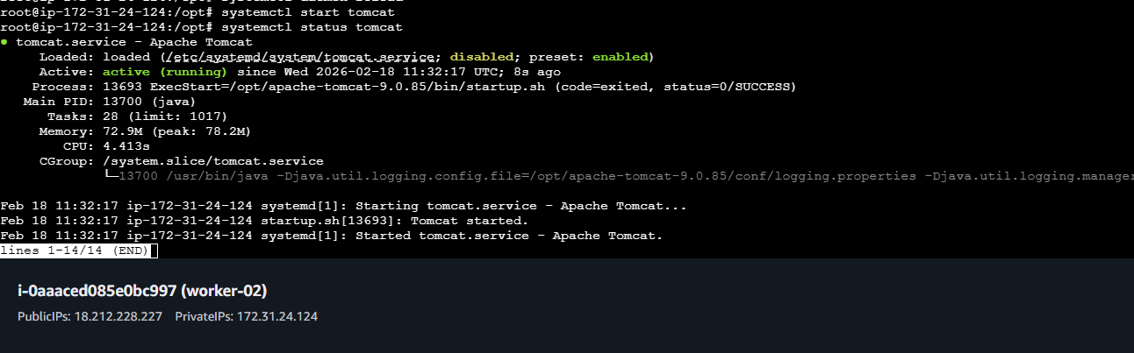
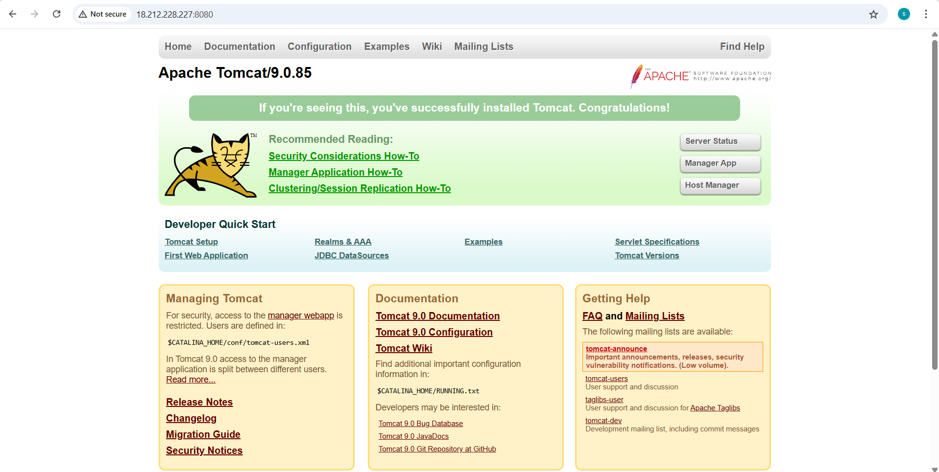

4.Write a ansible playbook to provision one ec2 on aws.
To copy a file from node-1 (worker-01) to node-2 (worker-02) using an Ansible playbook by fetching the file to the control node and then copying it to the destination node.
- Prerequisites
- Ansible installed on control node
- SSH connectivity between control node and worker nodes
- Inventory file configured with worker-01 and worker-02
- Root or sudo access on all nodes
- Source file available on node-1

- Steps Performed:
Step 1: Verify Source File on Node-1
- Logged into worker-01.
- Verified that the file exists in /opt.
ls /tmp/sample.txt

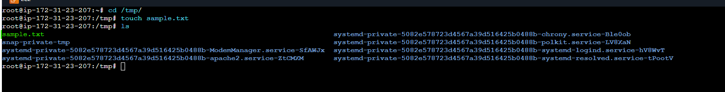

- Create Ansible Playbook

- Created a playbook file named copy_node1_to_node2.yml.
- Defined two plays:
  - First play to fetch the file from node-1 to the control node
  - Second play to copy the file from control node to node-2
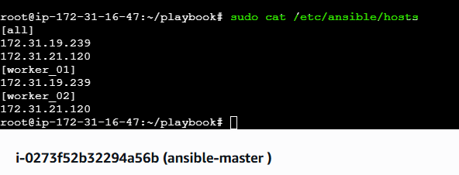
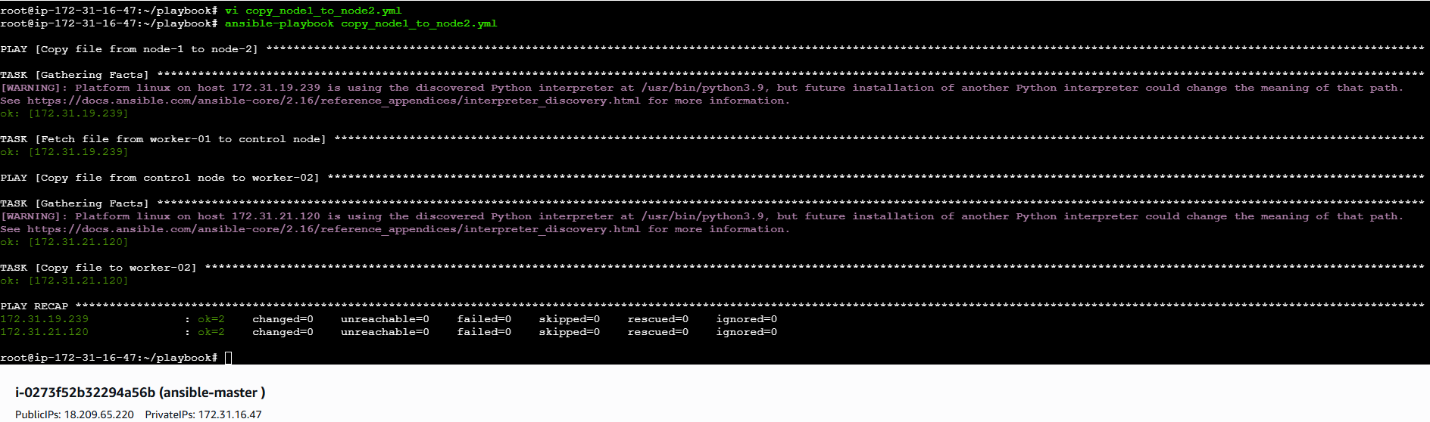
---
- name: Copy file from node-1 to node-2
hosts: worker_01
become: yes
tasks:
- name: Fetch file from worker-01 to control node
fetch:
src: /tmp/sample.txt
dest: /tmp/sample.txt
flat: yes
- name: Copy file from control node to worker-02
hosts: worker_02
become: yes
tasks:
- name: Copy file to worker-02
copy:
src: /tmp/sample.txt
dest: /tmp/sample.txt
- Execute the Ansible Playbook
- Ran the playbook from the control node.
- The file was successfully fetched from node-1 and copied to node-2.
ansible-playbook copy_node1_to_node2.yml
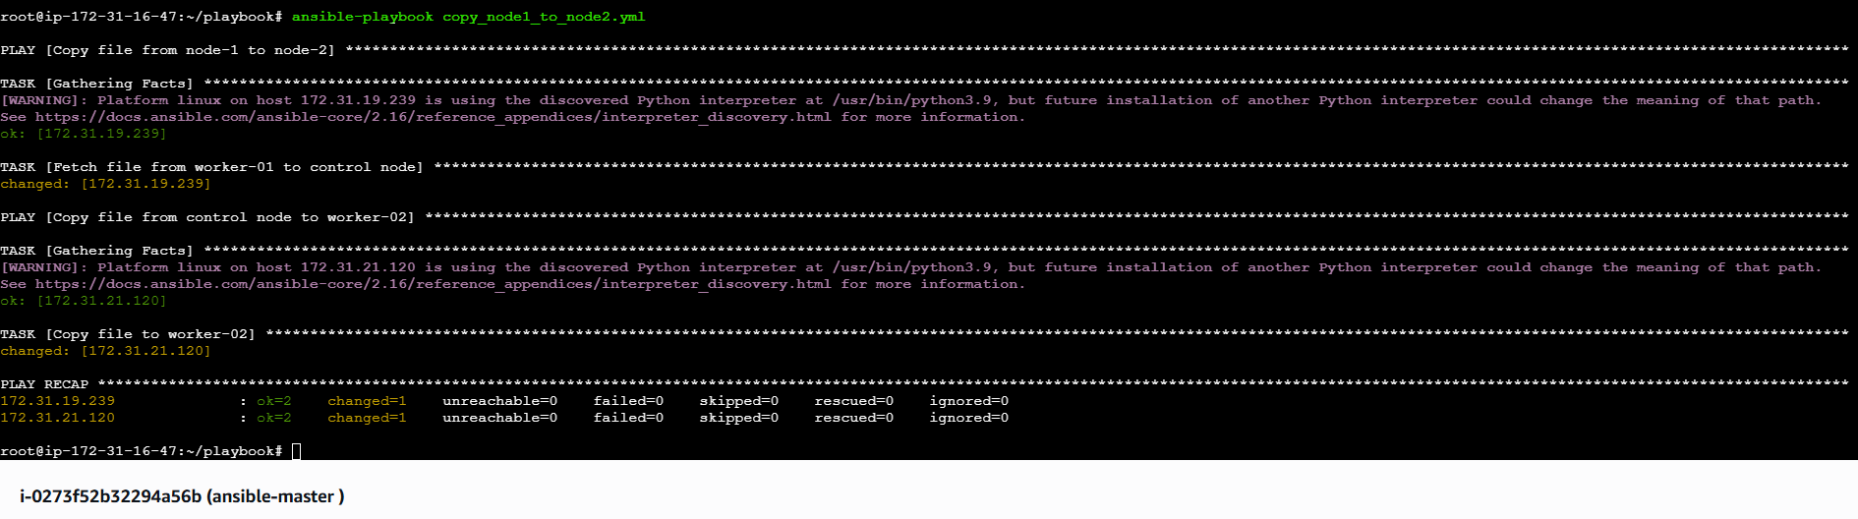
- Verify File on Node-2
- Logged into worker-02.
- Verified that the file exists in /tmp.
ls /tmp/sample.txt
- Validation Steps
- File exists on node-1 before execution
- Playbook executed without errors
- File successfully copied to node-2
- File content remains unchanged

5 .Write a ansible playbook to create different files with different names using single playbook.

To create multiple files with different names on managed nodes using a single Ansible playbook by leveraging looping functionality.
- Prerequisites
- Ansible installed on control node
- SSH connectivity to managed nodes
- Inventory file configured correctly
- Root or sudo privileges on target nodes
- Steps Performed:
Step 1: Create Ansible Playbook File
- Created a playbook file named create_multiple_files.yml inside the playbooks directory.
vi create_multiple_files.yml
Step 2: Write the Playbook to Create Multiple Files
- Defined target hosts and enabled privilege escalation.
- Used the file module with a loop to create multiple files with different names in /tmp.

---
- name: Create multiple files using single playbook
hosts: all
become: yes

tasks:
- name: Create different files
file:
path: "/tmp/{{ item }}"
state: touch
loop:
- world.txt
- hello.txt
- test.txt
- tiger.txt

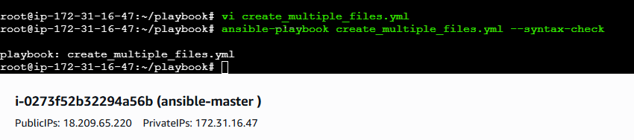
Step 3: Execute the Ansible Playbook
- Ran the playbook using the Ansible command.
- The playbook executed successfully on all target nodes.
ansible-playbook create_multiple_files.yml
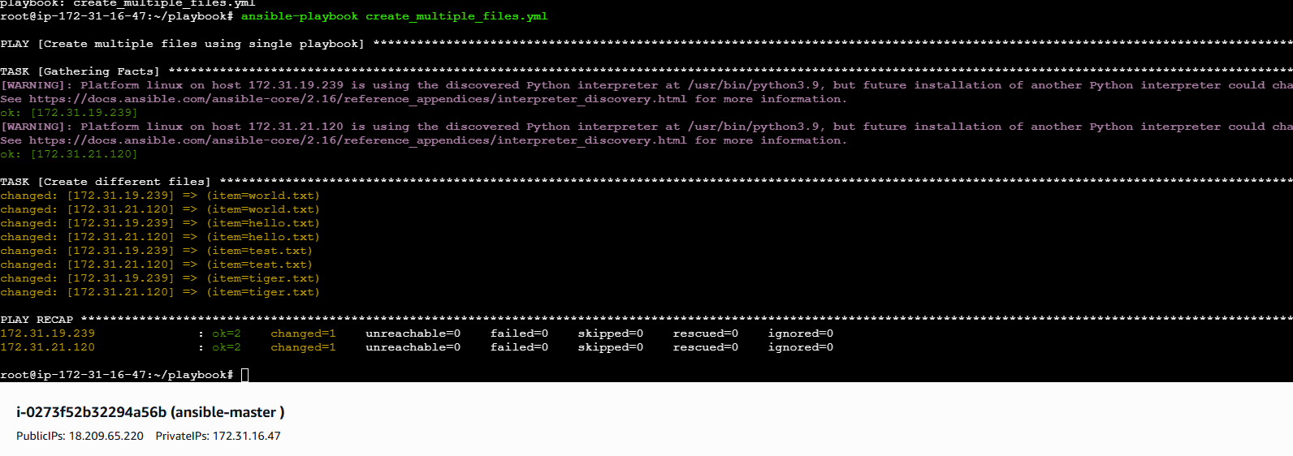
Step 4: Verify File Creation on Target Nodes
- Logged into each managed node.
- Verified that all specified files were created successfully in the /tmp directory.
ls /tmp
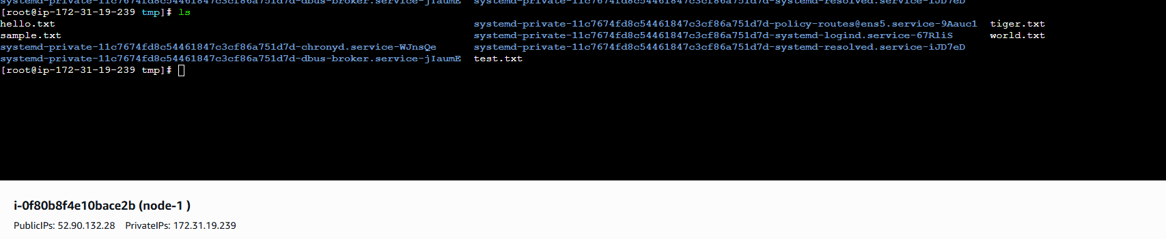
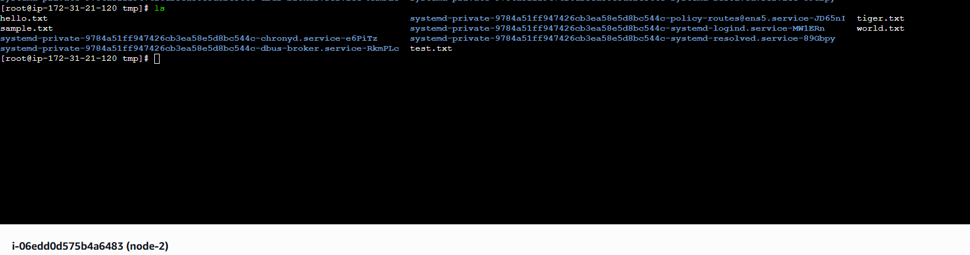
Validation Steps
- Playbook executed without errors
- All specified files were created on target nodes
- File names matched the loop entries

